**MODULE 1**

1. **What is software? What is software engineering?**
   * Software is a set of instruction, data, or program used to operate computers and execute specific tasks.
   * Software engineering is defined as a process of analyzing user requirements and then designing, building, and testing software application which will satisfy those requirements.
2. **Explain types of software**
   * Application software
   * System software
   * Driver software
   * Middleware
   * Programming software
3. **What is SDLC? Explain each phase of SDLC**
   * Software development life cycle (SDLC) refers to a methodology with clearly defined process for creating high quality software.
   * The SDLC focuses on following phases of the software development.
4. Requiremnt Gathering
5. Analysis
6. Degining
7. Implementation
8. Testing
9. Maintenance
10. **Requirement Gathering:-**

In this stage where you are gathering requirement from your client or stackholder.

1. **Anaysis:-**

In this stage where you are looking into feasibility of creating the product, revenue potential, the cost of production, the needs of the users etc. once it decided that the software or update is in line with business goals. Feasible to create, and addresses user needs and then you move to third stage.

1. **Designing:-**

The design phase is where you put pen to paper. The original plan and vision is elaborated into the basic structure of the software, including the system design, programming language, templates, platform to use, and application security measures. This is also where you can flowchart how the software responds to user action.

1. **Implementation:-**

The actual development phase is where development team turns product specification and business requirements into code that makes the product.

This SDLC phase can take quite a lot of time. It’s important to have a set timeline and milestone so the software developers understand the expectations and you can keep track the progress.

1. **Testing:-**

Before getting the software product out the door, it’s important to have your quality assurance team test it to make sure it is functioning properly and does what it’s meant to do.

1. **Maintenance:-**

In the maintenance phase , users may find bugs and errors that were missed in the earlier testing phase. These bugs need to be fixed for better user experience and retention.

1. **What is DFD? Create a DFD diagram on Flipkart**
   * + - DFD stands for “Data Flow Diagram”.It is also known as a “Bubble Chart”.
       - Through which we can represent the flow of data graphically on an information system.
       - By using DFD we can easily understand the overall functionality of the system because the diagram represent the incoming data, outgoing data flow and stores data in a graphical form.
       - It describes how data is processed in a system in terms of input & output.

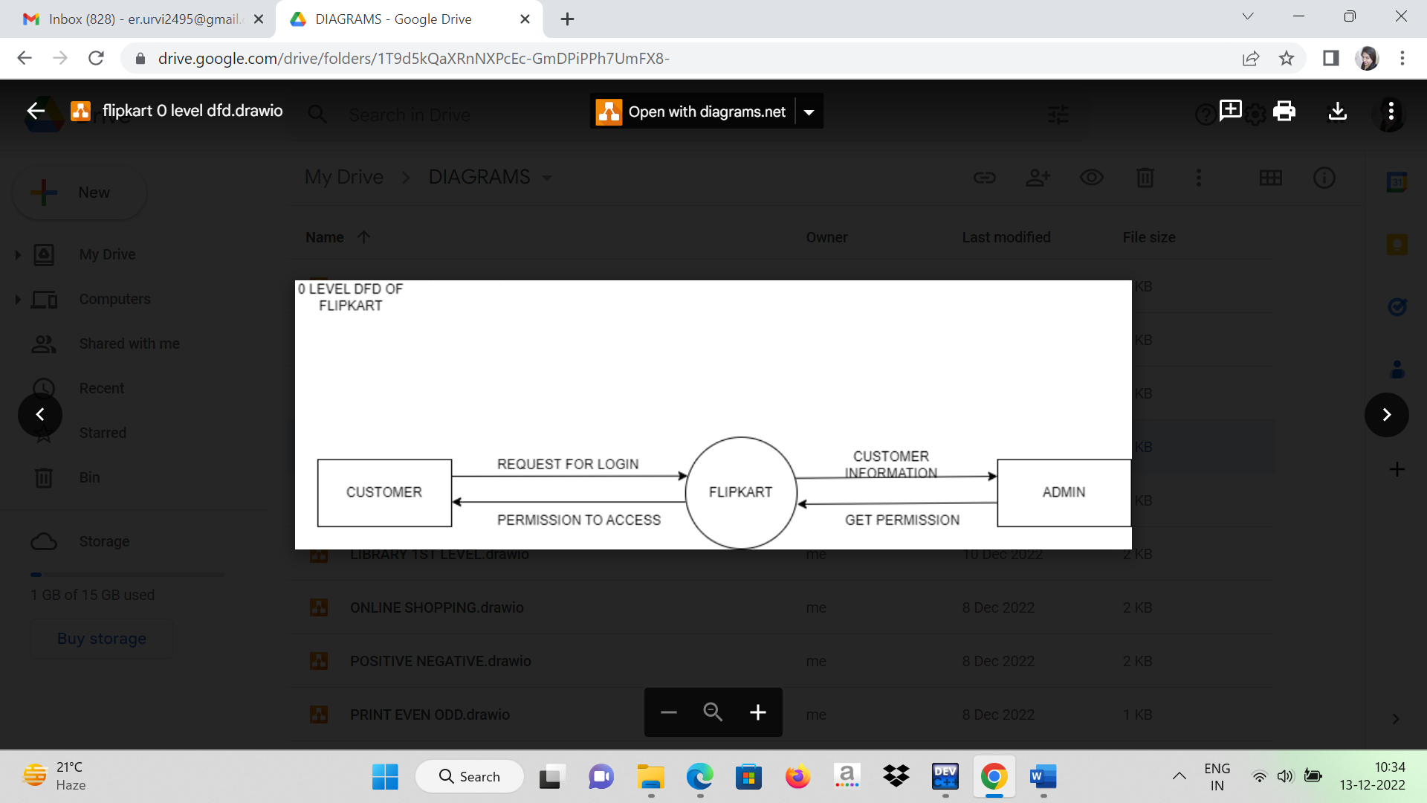

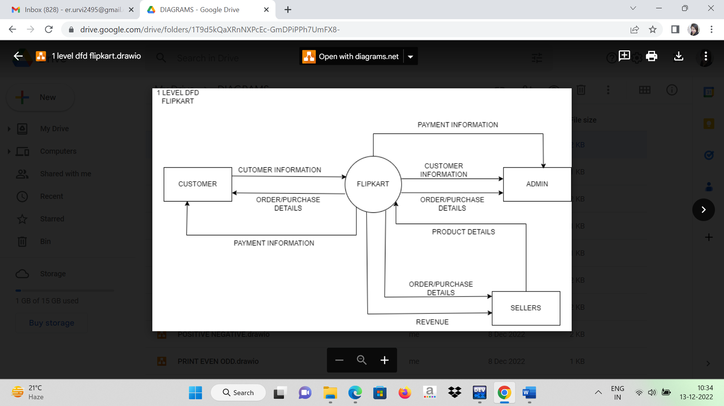

1. **What is Flow chart? Create a flowchart to make addition of two numbers**

 flowchart is a type of diagram that represents a workflow or process. A flowchart can also be defined as a diagrammatic representation of an algorithm, a step-by-step approach to solving a task.

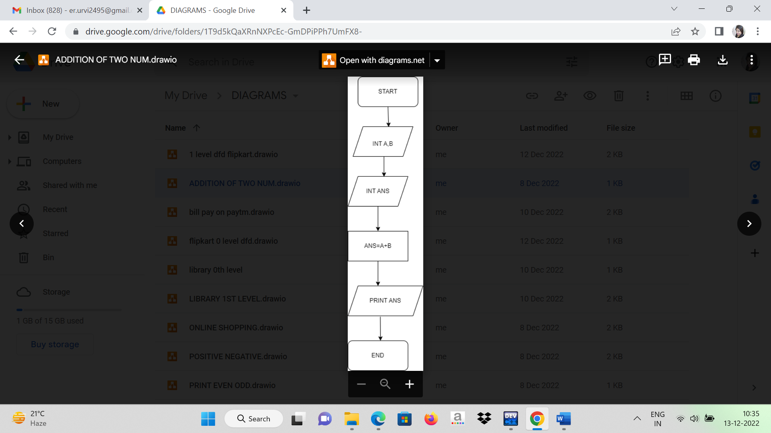

1. **What is Use case Diagram? Create a use-case on bill payment on paytm**

A use case diagram is a graphical depiction of a user's possible interactions with a system.

